Mutually Conflicting Requirements
Mahmudul Alam
Colorado State University Global
20WA-CSC505-1
Wednesday, December 23, 2020

Software is an essential part of today’s society. There is use of software in every aspect of our lives. Every kind of business and every government system uses software today. Throughout the history of mankind whatever was essential to people was heavily protected and carefully thought through. Such entity was closely wanted and participated by the people and watched over by the government. Software is one of such entity that will play big roles in coming days therefore we must include both the users and the regulators to be part of the development. A software development requires integration of many systems and features. Often software can be complex, and it requires the development team to break down the whole project into small tasks or portions.
Waterfall has been big part of software development process for years, but modern software development requires the inclusion of people and the government and in the process agile was born. “Another main advantage of an Agile approach is that it facilitates transition, unlike a Waterfall model. Although the team must remain centered throughout each iteration on producing an agreed-to subset of the functionality of the product, there is an ability to continuously optimize and reprioritize the overall product backlog.” (Systems) to deal with the changing requirements agile can be effective. Agile allows stakeholders and users to request change while the software is being developed, in each phase we can involve them to better build the system. Sometimes two stakeholders who have conflicting ideas about the specifications. In particular, they may disagree on what the software should be. This phenomenon is known as "mutually conflicting requirements." In other words, conflicting requirements are an issue that arises when a requirement is incompatible with another requirement. A process follow chart can be used to better define structure of a software development. According to the diagram below we clearly see how important communication is throughout the development process. I think we are lacking communicating right, we do involve stakeholders and developers but often times we forget to include the users.
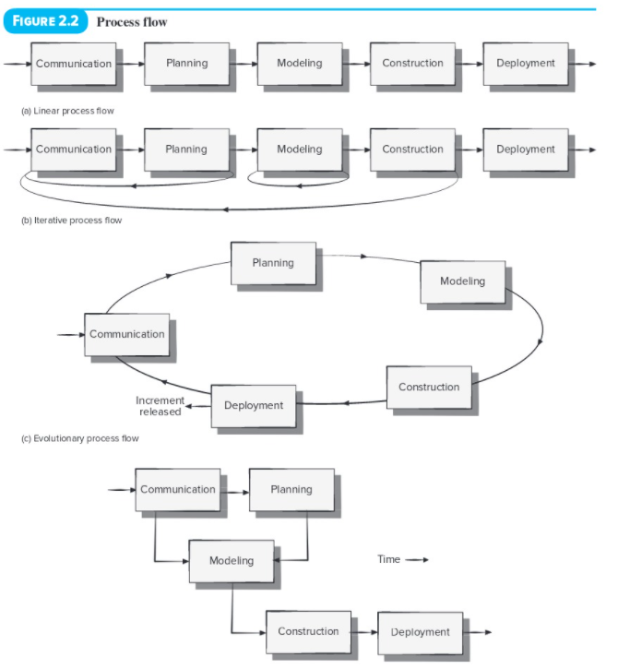
Figure 1 International Journal of Advanced Computer Science and Applications
Users are key a successful built software. If we can include the users in every stage of the development process, we can have better user friendly and user accepted software products. The diagram below of the user involvement clearly shows how should we involve the users and how we can evaluate their feedback for a live software or even in the development phase.
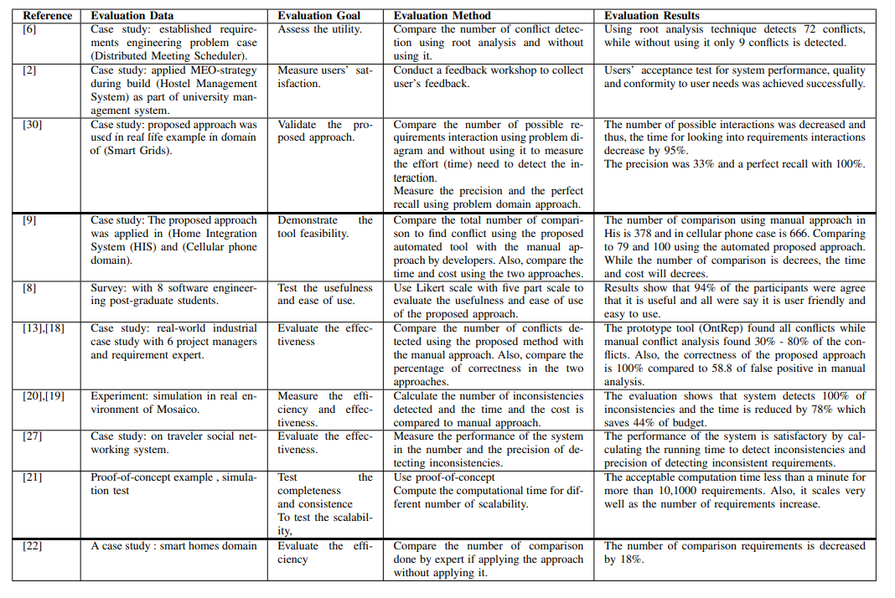
Figure 2 Pressman, R. & Maxim, B. (2020)
There is no other between ways to involve users in every phase of the development process. Agile allows us to add users on every stage, if we can involve users directly, we should add and review their comments collected from surveys and from other methods. I have created the communication matrix to better deal with the mutually conflicting requirements and involving users on every phase of the development process.
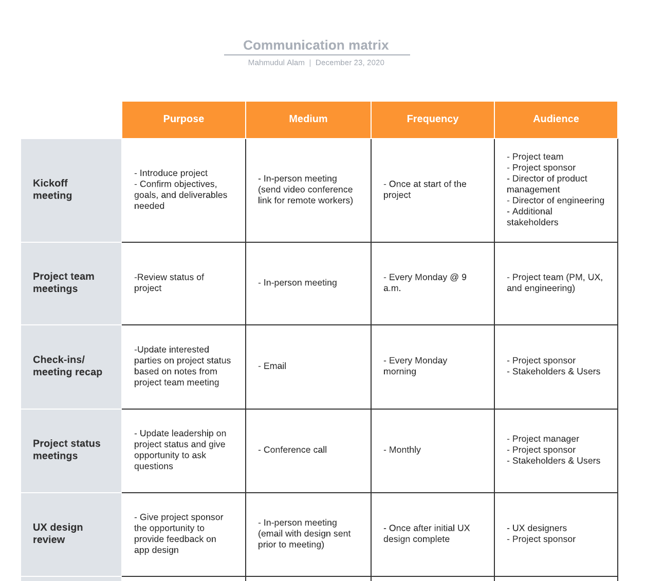
Software is for the people therefore it should be by the people. Stakeholders might pay for the software initially but in long run they will make money out of the people/user. Everyone should prioritize the users and their recommendations because they are the one who is use the software at the end. Governing body should regulate and mandate the development companies to include users during the development phase Afterall they will be paying for the product.

References
International Journal of Advanced Computer Science and Applications Vol. 7, No. 10. (2016,
October). Retrieved December, 2020, from www.ijacsa.thesai.org
Pressman, R. & Maxim, B. (2020). Software engineering: A practitioner’s approach (9th ed.).
New York, NY: McGraw Hill. ISBN-13: 9781259872976
Systems, B. (n.d.). Benefits and Challenges of Agile Development. Retrieved December 24, 2020, from https://www.blueprintsys.com/agile-development-101/agile-benefits-and-challenges

